

root@cyberster:~$ whoami
> hanzallah — soc_intern
DAY
22-23
pfSense Firewall Setup & Network Segmentation
// candidate Hanzallah
// program Cyberster — Cybersecurity Internship (Batch 2)
// tutor Abdullah Zia
[ STATUS: TASKS COMPLETE — READY FOR REVIEW ]

// 22-23 OVERVIEW & SCOPE

This phase introduced pfSense as a dedicated firewall/router VM, converting the lab from a flat network where all VMs communicated directly to a segmented topology where all inter-VM traffic is routed and filtered through pfSense. pfSense's WAN interface faces outward for internet access; its LAN interface (192.168.56.2/24) sits on the existing Host-Only network alongside Ubuntu Server / Wazuh Manager (192.168.56.10), Kali (192.168.56.102), and the Windows 10 agent. Ubuntu Server, Windows 10, and Kali were repointed to pfSense as their default gateway.
This was the most invasive lab reconfiguration to date, touching the network settings of every VM, and was executed incrementally — one VM at a time — with connectivity and Wazuh agent status verified after each change, to avoid debugging a fully broken network blind.
// 01 PFSENSE INSTALLATION & BOOT TROUBLESHOOTING

The pfSense Community Edition ISO was downloaded and a new VirtualBox VM was created with two network adapters (WAN / LAN). Installation surfaced two distinct boot failures before pfSense would run, both resolved through VirtualBox configuration changes rather than reinstallation.
$ Issue 1 — "CPU doesn't support long mode"
The FreeBSD-based installer refused to boot the 64-bit kernel despite the host CPU supporting virtualization. Root cause was two-fold:
- Windows Hyper-V was active (hypervisorlaunchtype: Auto), holding exclusive access to VT-x and preventing VirtualBox from exposing true 64-bit long mode to the guest.
- The VM's guest OS type was not correctly set to a 64-bit FreeBSD type, so PAE/NX was not being forced on for the guest.
Resolved by setting VirtualBox's Paravirtualization Interface to Hyper-V (allowing VirtualBox to run on top of Windows' hypervisor platform rather than requiring exclusive access) and correcting the VM's guest OS type to FreeBSD (64-bit), which re-enabled PAE/NX.
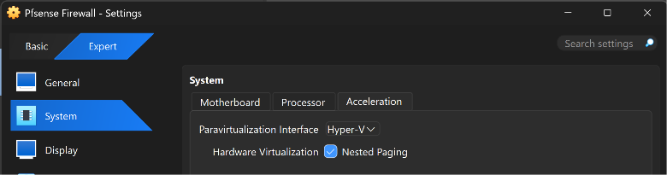
VirtualBox Acceleration settings — Hyper-V paravirtualization interface, Nested Paging enabled
$ Issue 2 — Kernel panic: "running without device atpic requires a local APIC"
With long mode resolved, the kernel began loading but panicked immediately after entering the FreeBSD boot sequence. This is a known VirtualBox/FreeBSD compatibility issue caused by the I/O APIC being disabled in the virtual chipset.
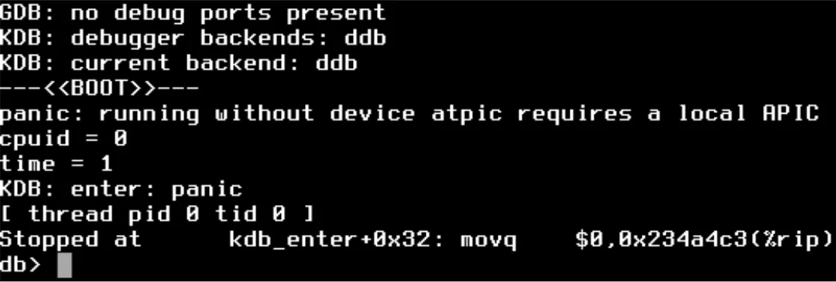
Resolved via VM Settings → System → Motherboard: enabled "I/O APIC" and confirmed the chipset was set to ICH9 for improved APIC/ACPI emulation support. pfSense booted successfully afterward.
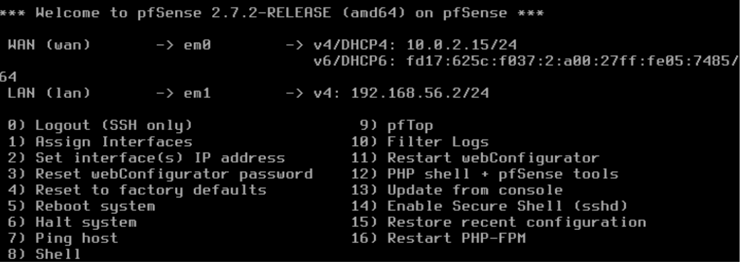
pfSense console showing successful boot to interface assignment menu

// 02 NETWORK TOPOLOGY CONFIGURATION

The task explicitly warns that WAN/LAN interface assignment is a common point of failure. In this build, the misconfiguration was not a swapped assignment but an incorrect network type: the WAN adapter was initially attached to the same Host-Only network as LAN, rather than NAT/Bridged.
$ Symptom
pfSense's console reported WAN and LAN both resolving into the 192.168.56.0/24 range (WAN via DHCP at .104, LAN statically at .1). With both interfaces on one subnet, pfSense treats this as an interface conflict and blocks traffic, including access to the webConfigurator — resulting in ERR_CONNECTION_REFUSED from the host browser.

$ Fix
- WAN adapter (Adapter 1) changed from Host-Only to NAT.
- LAN adapter (Adapter 2) confirmed on the Host-Only network shared with the rest of the lab.
After the change, WAN correctly obtained an isolated address (10.0.2.15/24 via NAT) while LAN remained on 192.168.56.2/24, resolving the conflict.
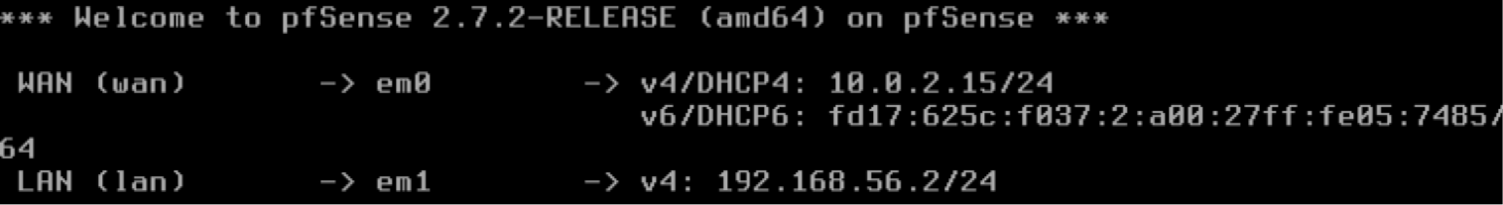
pfSense console — WAN on NAT (10.0.2.15/24) and LAN on Host-Only (192.168.56.2/24), correctly separated

// 03 LAN ADDRESSING & WEBCONFIGURATOR ACCESS

pfSense's LAN interface was assigned 192.168.56.2/24 — the conventional gateway address within the existing 192.168.56.0/24 lab subnet, avoiding collision with Ubuntu Server (.10) and Kali (.102). The webConfigurator was reached at https://192.168.56.1 from the host browser once the WAN/LAN network type conflict above was resolved.
Default webConfigurator credentials (admin / pfsense) were used for initial login, then changed via System → User Manager to a lab-specific password.

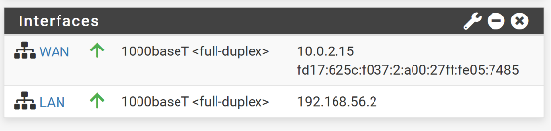
pfSense dashboard — WAN and LAN interfaces both up, traffic statistics panel visible

// 04 DEFAULT GATEWAY RECONFIGURATION

All three lab VMs were repointed to pfSense's LAN IP (192.168.56.2) as their default gateway, one at a time, with connectivity and Wazuh agent status verified after each change before proceeding to the next.
$ Ubuntu Server
Netplan configuration updated to set the default route via 192.168.56.2 while retaining the static address 192.168.56.10/24:
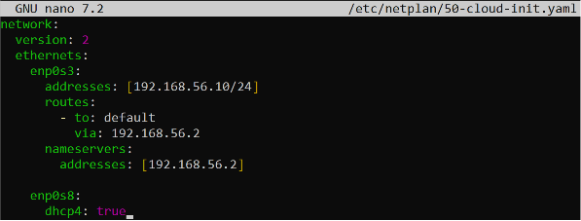
Applied with sudo netplan apply and verified with ping 192.168.56.2. Wazuh Manager services remained unaffected since the host IP itself did not change — only the outbound route.
$ Windows 11
Default gateway updated to 192.168.56.2 via the network adapter's IPv4 properties. Connectivity to pfSense confirmed via ping; win10-vm agent status confirmed Active in the Wazuh dashboard post-change.
$ Kali Linux
Gateway updated to 192.168.56.2 in the network interface configuration. Connectivity and Wazuh agent status confirmed as with the other two hosts.
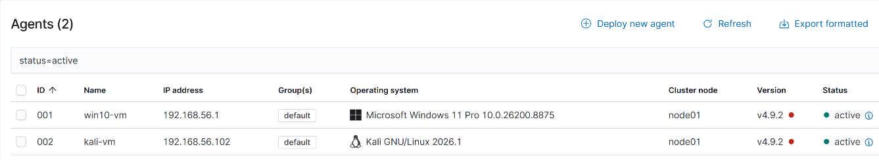
Wazuh dashboard — all three agents (Ubuntu, Windows, Kali) showing Active status post-gateway change

// 05 FIREWALL RULES & LOGGING

Firewall rules were configured on the LAN interface (Firewall → Rules → LAN) with logging explicitly enabled — an unlogged rule provides no visibility into what traffic it actually matched, which defeats the purpose of this exercise.
$ Rules configured
- Default LAN allow rule — logging enabled. Establishes a baseline audit trail of all outbound LAN traffic passing through pfSense.
- Allow + log ICMP, LAN net → LAN net. Isolates ping/diagnostic traffic between lab VMs specifically, useful for confirming connectivity events are visible in the logs.
- Allow + log traffic destined to 192.168.56.10 (Wazuh Manager). Isolates traffic hitting the Wazuh host specifically, separating agent/manager communication from general LAN chatter in the log stream.
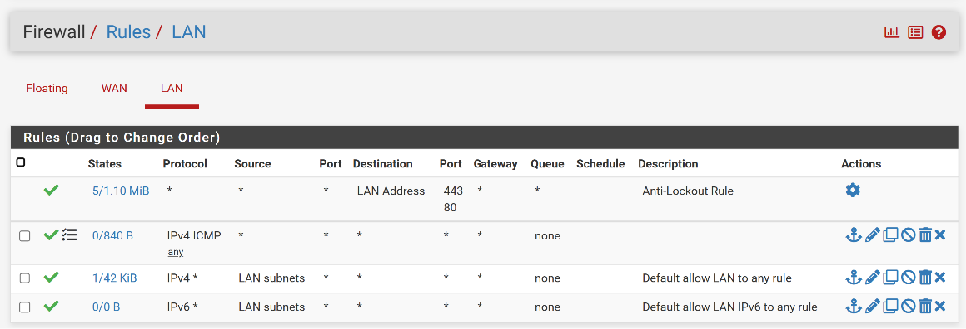
pfSense Firewall → Rules → LAN, showing configured rules with logging enabled

// 06 SYSLOG FORWARDING TO WAZUH

pfSense's remote syslog output (Status → System Logs → Settings) was configured to forward Firewall Events to the Wazuh Manager over UDP 514:
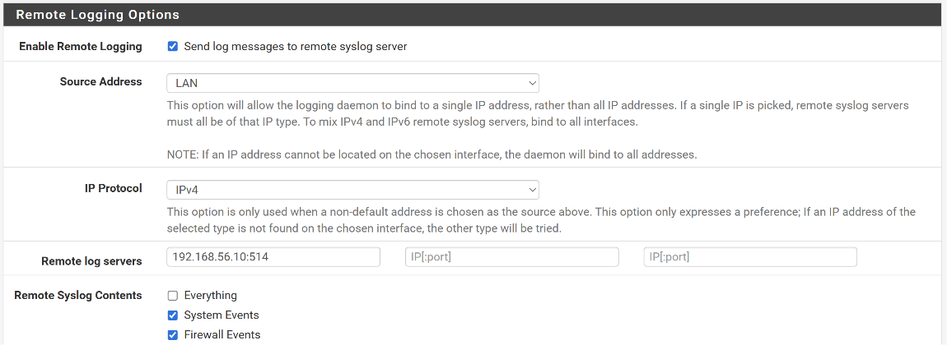
On the Wazuh Manager side, wazuh-remoted was confirmed already listening on UDP 514 across all interfaces:
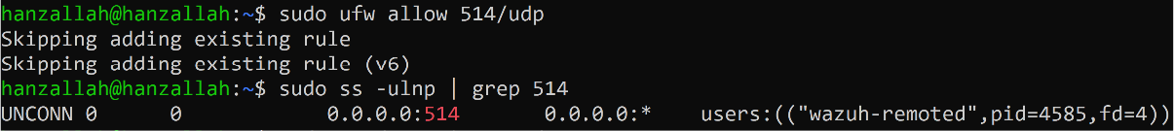
Delivery was verified independently of the Wazuh dashboard using tcpdump on the Ubuntu Server host, confirming pfSense was actively sending syslog traffic rather than relying solely on Wazuh's listener state:
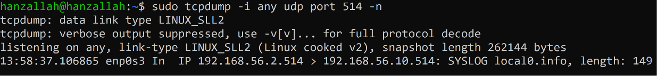
Note: the observed source address for forwarded syslog traffic was 192.168.56.2 rather than the LAN interface address 192.168.56.1. This did not affect delivery or the validity of the results and is noted here as an observed quirk for future investigation rather than a blocking issue.
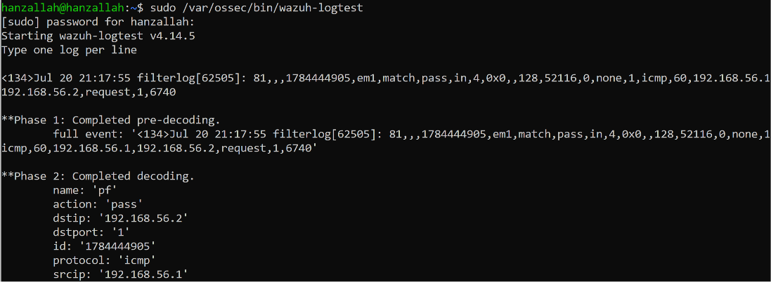
pfSense log entries appearing in the Wazuh dashboard, alert detail expanded showing parsed syslog fields

// 07 DELIVERABLES IN THIS REPORT

- pfSense dashboard screenshot — WAN and LAN interfaces up, traffic statistics visible.
- LAN firewall rules configuration with logging enabled, and written explanation of each rule's purpose.
- Confirmed UDP 514 syslog delivery from pfSense to Wazuh Manager (tcpdump-verified).
- Wazuh dashboard screenshots showing pfSense log entries with parsed syslog fields.

